**COSC 2P13:**

*SPOOLer Simulation Project analysis*

**Author: Long Nguyen**

*Brock University, Computer Science*

*500 Glenridge Ave, Saint Catharine, ON L2S 3A1*

**ABSTRACT**

This project simulates a network print spooler, which accept multiple simultaneous print requests and handle them gracefully with different queue methods. The program graphs the queue status, and allows users to see graphically what the response time for each queues with the detail of the average and maximum turn overtime.

**1. Introduction**

In operating systems, the response time is very crucial with multiple job requests. Although all jobs requests are linked by queues, this increases the response time, which causes the system to be sluggish and slow down. By observing and selecting the precise queue algorithms it can help reduce the total response time of any request. The purpose of analyzing the material is to provide a better understanding of the queue scheduling algorithms. A good print spooler should allow to change the order of the job request in the queue and to cancel specific print jobs.

***2.1 Why Print Spooler*** ***is necessary***

The problem with a printer in a lab is the numbers of job requests; each lab has one printer and many computers connected to the server. If there are two requests concurrently, the printer cannot print them off simultaneously. We need a management program to control the request, something like “Simultaneous Peripheral Operation On-Line” or known as a “Spooler”. The Spooler works as following, a print request is submitted to the spooler queue and each print job is printed off in an orderly fashion.

**3. Queue Algorithms**

**FIFO:** The printouts are produced in the order of the arrival time.

**SPJF:** Shortest print job first. The approach of this method is print queue is sorted in ascending order of by the numbers of pages.

**PAPQ:** Priority-aged print queue. The print queue is sorted in descending order of print job priority. How the priority is calculated, P = priority, A and B are carefully chosen constants. B multiply by T. Where T is time. The following equation looks like P = A + B*T

**LBAQ:** Length-based aged queue: Similar to PAPQ. The print queue is sorted n descending order of print job priority. The priority is calculated as P = (A + B*T)/L, where L is the numbers of pages.

***4. The simulation of Print Spooler***

* How the simulation was conducted, we assumed the printer is capable of printing 40 pages a minute. The average print job is 4 pages long, using Poisson distribution.
* The java code to generate the arrival time in the program looks as the following. Using Poisson distribution that simulates the inter-event arrival time, we want it to be exponential distribution.

//1 is really spread out and 9 is really close together

**return** 60*(Math.*log*(1.0-Math.*random*())/-mean);

* Which is the following formula.

**F(x)=1−e−λx**

* Where test each arrival time at different speed, 1 to 9. Where 1 is really spread out in the arrival time to where 9 is very close together in the arrival time.
* Here I’ve used the poissonGenerator library I used from <http://maths.uncommons.org/>
* This gives an average print job of 4 pages using Poisson distribution.
* The java code to generate the number of random pages using Poisson distribution.

Random randPages = **new** Random();

PoissonGenerator numberOfPages = **null**;

numberOfPages = **new** PoissonGenerator(4, randPages);

numberPage = numberOfPages.nextValue();

* We simulated each queue using the above statistics for FIFO, SPJF, PAPQ and LBAQ. And plotted the average turn around time and the maximum turn around time of the print request frequency.

FIFO:

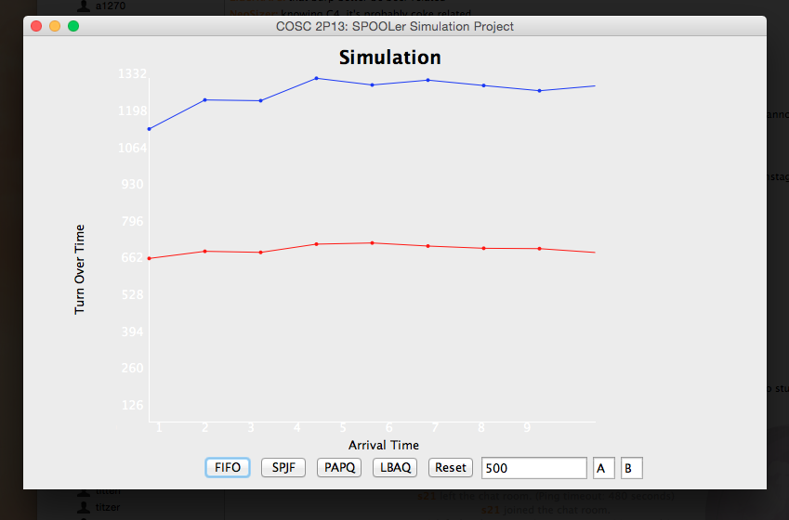

Tested with 500 jobs requested, showing the average in read and maximum turn over time in blue.

**FIFO:**

Speed is: 1 Average:634.25 Max: 1136.10

Speed is: 2 Average:661.88 Max: 1248.71

Speed is: 3 Average:657.75 Max: 1245.77

Speed is: 4 Average:689.69 Max: 1332.68

Speed is: 5 Average:694.25 Max: 1306.77

Speed is: 6 Average:682.29 Max: 1325.56

Speed is: 7 Average:673.61 Max: 1304.62

Speed is: 8 Average:672.25 Max: 1284.43

Speed is: 9 Average:657.29 Max: 1303.07

**SPJF:**

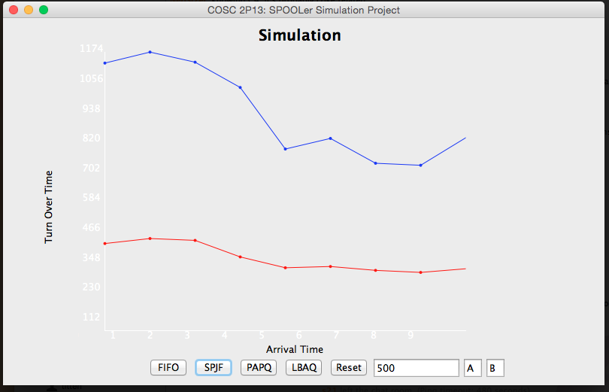

Tested with 500 jobs requested, showing the average in red and maximum turn over time in blue. Comparing this to FIFO, the average and max turn over time is max less.

**SPJF:**

Speed is: 1 Average:367.55 Max: 1128.51

Speed is: 2 Average:388.61 Max: 1174.84

Speed is: 3 Average:380.78 Max: 1132.24

Speed is: 4 Average:311.08 Max: 1025.60

Speed is: 5 Average:265.36 Max: 766.07

Speed is: 6 Average:270.63 Max: 810.80

Speed is: 7 Average:254.35 Max: 706.06

Speed is: 8 Average:245.68 Max: 697.53

Speed is: 9 Average:261.18 Max: 813.64

**PAPQ: P = A + B*T**

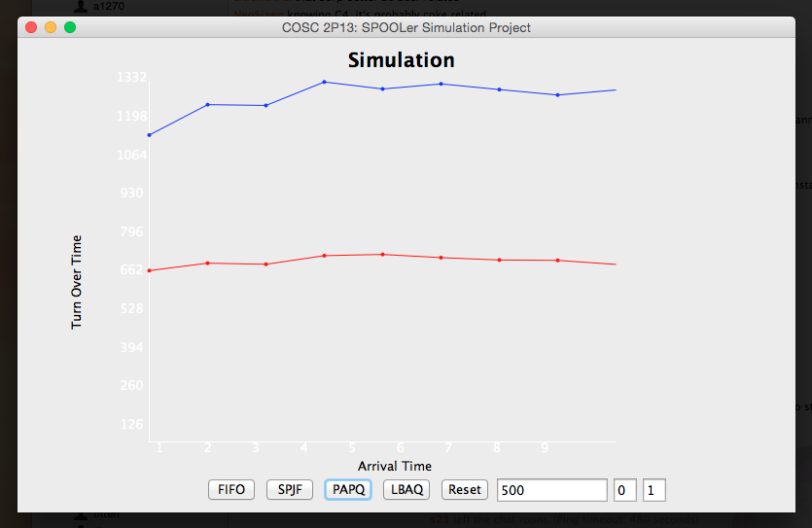

Tested with 500 jobs requested, where A = 0, B = 1. The Data from A: 0-4, to B: 1-3 are all the same. Exact same numbers across the broad with the average in red and maximum turn around time in blue. No need to show all the graphs if they are all the same. Below is the raw data showing that it’s all the same. PAPQ and FIFO is exactly the same with the same data.

PAPQ:

A: 0 B: 1

Speed is: 1 Average:634.25 Max: 1136.10

Speed is: 2 Average:661.88 Max: 1248.71

Speed is: 3 Average:657.75 Max: 1245.77

Speed is: 4 Average:689.69 Max: 1332.68

Speed is: 5 Average:694.25 Max: 1306.77

Speed is: 6 Average:682.29 Max: 1325.56

Speed is: 7 Average:673.61 Max: 1304.62

Speed is: 8 Average:672.25 Max: 1284.43

Speed is: 9 Average:657.29 Max: 1303.07

PAPQ:

A: 0 B: 2

Speed is: 1 Average:634.25 Max: 1136.10

Speed is: 2 Average:661.88 Max: 1248.71

Speed is: 3 Average:657.75 Max: 1245.77

Speed is: 4 Average:689.69 Max: 1332.68

Speed is: 5 Average:694.25 Max: 1306.77

Speed is: 6 Average:682.29 Max: 1325.56

Speed is: 7 Average:673.61 Max: 1304.62

Speed is: 8 Average:672.25 Max: 1284.43

Speed is: 9 Average:657.29 Max: 1303.07

PAPQ:

A: 0 B: 4

Speed is: 1 Average:634.25 Max: 1136.10

Speed is: 2 Average:661.88 Max: 1248.71

Speed is: 3 Average:657.75 Max: 1245.77

Speed is: 4 Average:689.69 Max: 1332.68

Speed is: 5 Average:694.25 Max: 1306.77

Speed is: 6 Average:682.29 Max: 1325.56

Speed is: 7 Average:673.61 Max: 1304.62

Speed is: 8 Average:672.25 Max: 1284.43

Speed is: 9 Average:657.29 Max: 1303.07

PAPQ:

A: 1 B: 1

Speed is: 1 Average:634.25 Max: 1136.10

Speed is: 2 Average:661.88 Max: 1248.71

Speed is: 3 Average:657.75 Max: 1245.77

Speed is: 4 Average:689.69 Max: 1332.68

Speed is: 5 Average:694.25 Max: 1306.77

Speed is: 6 Average:682.29 Max: 1325.56

Speed is: 7 Average:673.61 Max: 1304.62

Speed is: 8 Average:672.25 Max: 1284.43

Speed is: 9 Average:657.29 Max: 1303.07

PAPQ:

A: 1 B: 2

Speed is: 1 Average:634.25 Max: 1136.10

Speed is: 2 Average:661.88 Max: 1248.71

Speed is: 3 Average:657.75 Max: 1245.77

Speed is: 4 Average:689.69 Max: 1332.68

Speed is: 5 Average:694.25 Max: 1306.77

Speed is: 6 Average:682.29 Max: 1325.56

Speed is: 7 Average:673.61 Max: 1304.62

Speed is: 8 Average:672.25 Max: 1284.43

Speed is: 9 Average:657.29 Max: 1303.07

PAPQ:

A: 1 B: 4

Speed is: 1 Average:634.25 Max: 1136.10

Speed is: 2 Average:661.88 Max: 1248.71

Speed is: 3 Average:657.75 Max: 1245.77

Speed is: 4 Average:689.69 Max: 1332.68

Speed is: 5 Average:694.25 Max: 1306.77

Speed is: 6 Average:682.29 Max: 1325.56

Speed is: 7 Average:673.61 Max: 1304.62

Speed is: 8 Average:672.25 Max: 1284.43

Speed is: 9 Average:657.29 Max: 1303.07

PAPQ:

A: 2 B: 1

Speed is: 1 Average:634.25 Max: 1136.10

Speed is: 2 Average:661.88 Max: 1248.71

Speed is: 3 Average:657.75 Max: 1245.77

Speed is: 4 Average:689.69 Max: 1332.68

Speed is: 5 Average:694.25 Max: 1306.77

Speed is: 6 Average:682.29 Max: 1325.56

Speed is: 7 Average:673.61 Max: 1304.62

Speed is: 8 Average:672.25 Max: 1284.43

Speed is: 9 Average:657.29 Max: 1303.07

PAPQ:

A: 2 B: 2

Speed is: 1 Average:634.25 Max: 1136.10

Speed is: 2 Average:661.88 Max: 1248.71

Speed is: 3 Average:657.75 Max: 1245.77

Speed is: 4 Average:689.69 Max: 1332.68

Speed is: 5 Average:694.25 Max: 1306.77

Speed is: 6 Average:682.29 Max: 1325.56

Speed is: 7 Average:673.61 Max: 1304.62

Speed is: 8 Average:672.25 Max: 1284.43

Speed is: 9 Average:657.29 Max: 1303.07

PAPQ:

A: 2 B: 4

Speed is: 1 Average:634.25 Max: 1136.10

Speed is: 2 Average:661.88 Max: 1248.71

Speed is: 3 Average:657.75 Max: 1245.77

Speed is: 4 Average:689.69 Max: 1332.68

Speed is: 5 Average:694.25 Max: 1306.77

Speed is: 6 Average:682.29 Max: 1325.56

Speed is: 7 Average:673.61 Max: 1304.62

Speed is: 8 Average:672.25 Max: 1284.43

Speed is: 9 Average:657.29 Max: 1303.07

PAPQ:

A: 3 B: 1

Speed is: 1 Average:634.25 Max: 1136.10

Speed is: 2 Average:661.88 Max: 1248.71

Speed is: 3 Average:657.75 Max: 1245.77

Speed is: 4 Average:689.69 Max: 1332.68

Speed is: 5 Average:694.25 Max: 1306.77

Speed is: 6 Average:682.29 Max: 1325.56

Speed is: 7 Average:673.61 Max: 1304.62

Speed is: 8 Average:672.25 Max: 1284.43

Speed is: 9 Average:657.29 Max: 1303.07

PAPQ:

A: 3 B: 2

Speed is: 1 Average:634.25 Max: 1136.10

Speed is: 2 Average:661.88 Max: 1248.71

Speed is: 3 Average:657.75 Max: 1245.77

Speed is: 4 Average:689.69 Max: 1332.68

Speed is: 5 Average:694.25 Max: 1306.77

Speed is: 6 Average:682.29 Max: 1325.56

Speed is: 7 Average:673.61 Max: 1304.62

Speed is: 8 Average:672.25 Max: 1284.43

Speed is: 9 Average:657.29 Max: 1303.07

PAPQ:

A: 3 B: 4

Speed is: 1 Average:634.25 Max: 1136.10

Speed is: 2 Average:661.88 Max: 1248.71

Speed is: 3 Average:657.75 Max: 1245.77

Speed is: 4 Average:689.69 Max: 1332.68

Speed is: 5 Average:694.25 Max: 1306.77

Speed is: 6 Average:682.29 Max: 1325.56

Speed is: 7 Average:673.61 Max: 1304.62

Speed is: 8 Average:672.25 Max: 1284.43

Speed is: 9 Average:657.29 Max: 1303.07

PAPQ:

A: 4 B: 1

Speed is: 1 Average:634.25 Max: 1136.10

Speed is: 2 Average:661.88 Max: 1248.71

Speed is: 3 Average:657.75 Max: 1245.77

Speed is: 4 Average:689.69 Max: 1332.68

Speed is: 5 Average:694.25 Max: 1306.77

Speed is: 6 Average:682.29 Max: 1325.56

Speed is: 7 Average:673.61 Max: 1304.62

Speed is: 8 Average:672.25 Max: 1284.43

Speed is: 9 Average:657.29 Max: 1303.07

PAPQ:

A: 4 B: 2

Speed is: 1 Average:634.25 Max: 1136.10

Speed is: 2 Average:661.88 Max: 1248.71

Speed is: 3 Average:657.75 Max: 1245.77

Speed is: 4 Average:689.69 Max: 1332.68

Speed is: 5 Average:694.25 Max: 1306.77

Speed is: 6 Average:682.29 Max: 1325.56

Speed is: 7 Average:673.61 Max: 1304.62

Speed is: 8 Average:672.25 Max: 1284.43

Speed is: 9 Average:657.29 Max: 1303.07

PAPQ:

A: 4 B: 4

Speed is: 1 Average:634.25 Max: 1136.10

Speed is: 2 Average:661.88 Max: 1248.71

Speed is: 3 Average:657.75 Max: 1245.77

Speed is: 4 Average:689.69 Max: 1332.68

Speed is: 5 Average:694.25 Max: 1306.77

Speed is: 6 Average:682.29 Max: 1325.56

Speed is: 7 Average:673.61 Max: 1304.62

Speed is: 8 Average:672.25 Max: 1284.43

Speed is: 9 Average:657.29 Max: 1303.07

PAPQ: P = A + B*T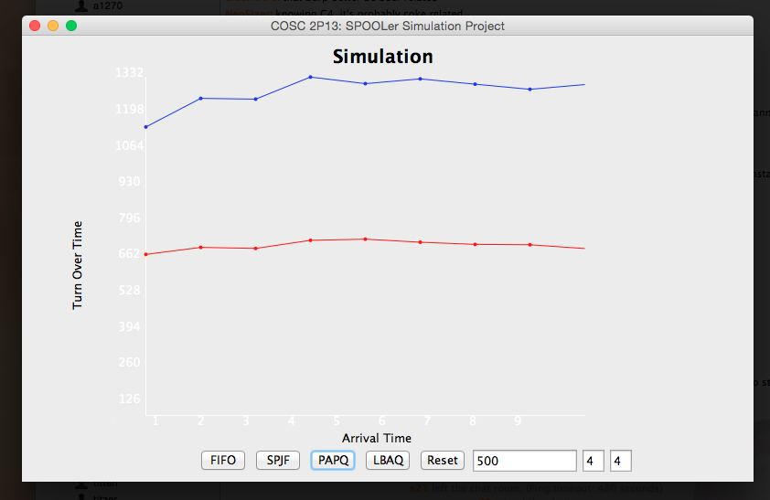

Tested with 500 jobs requested, where A = 4, B = 4. PAPQ A:0, B:1 to A:4 to B:4 are all the same data, graphically . No need to show the other 10 graphs for this queue.

LBAQ:

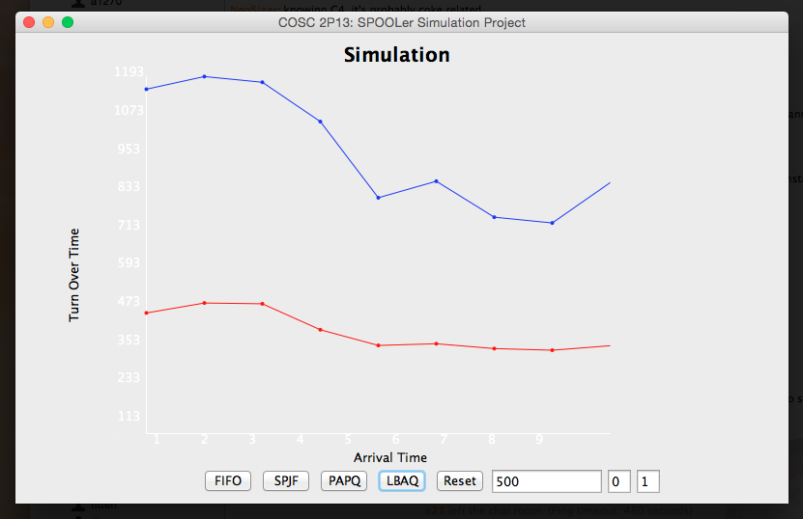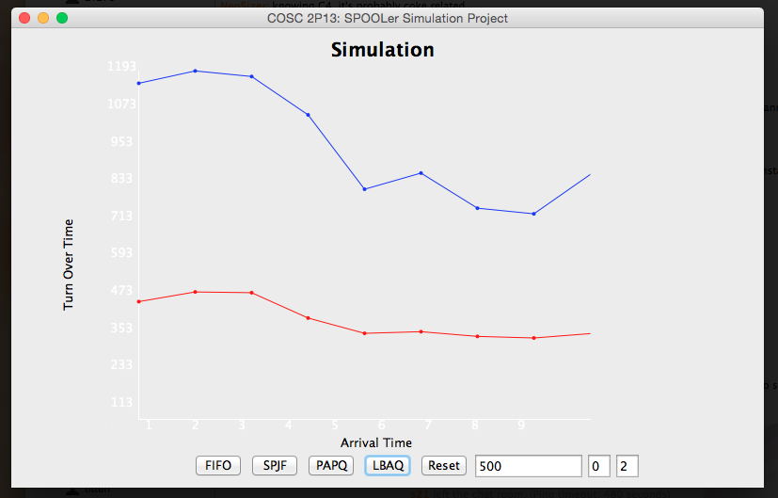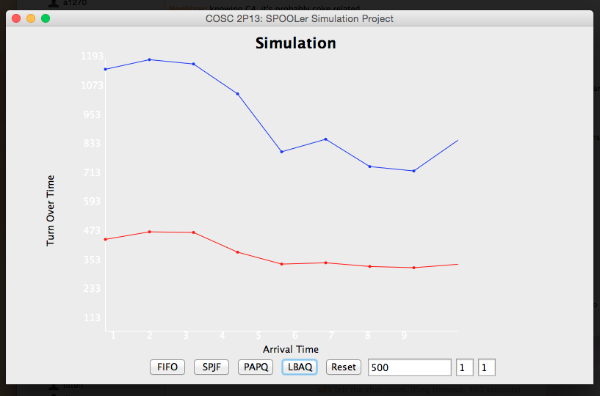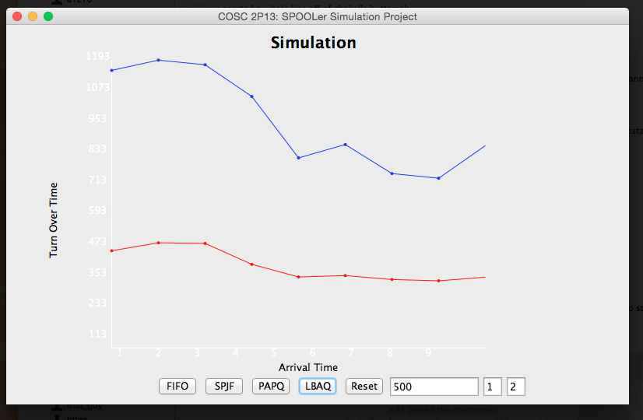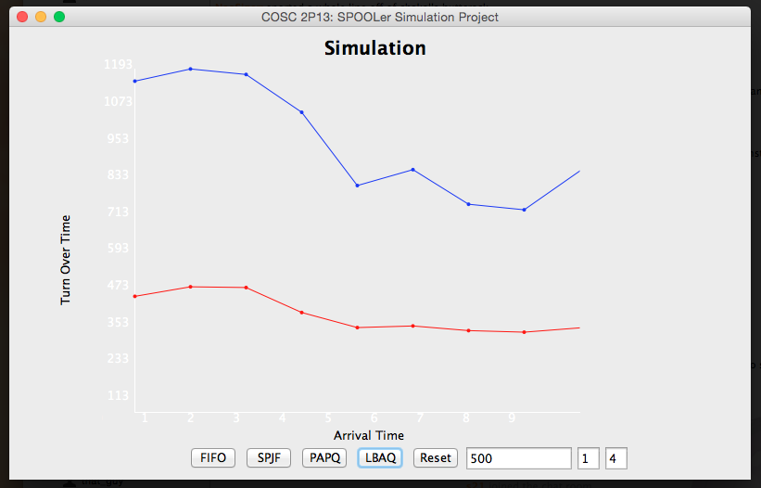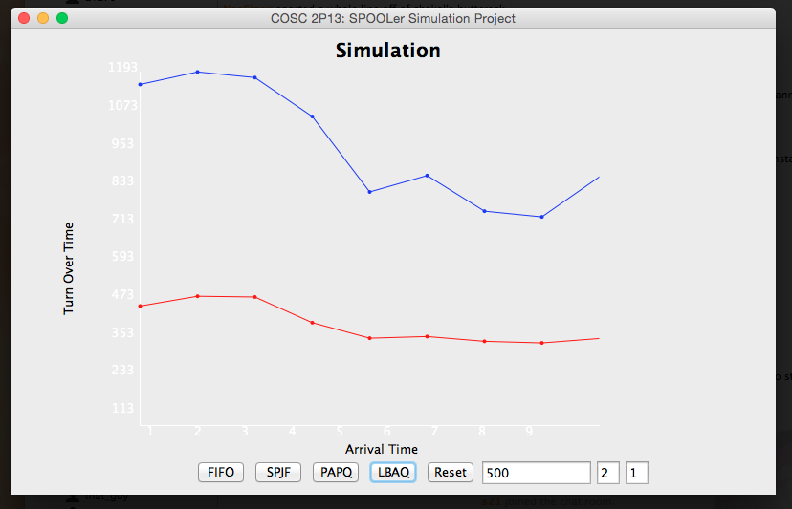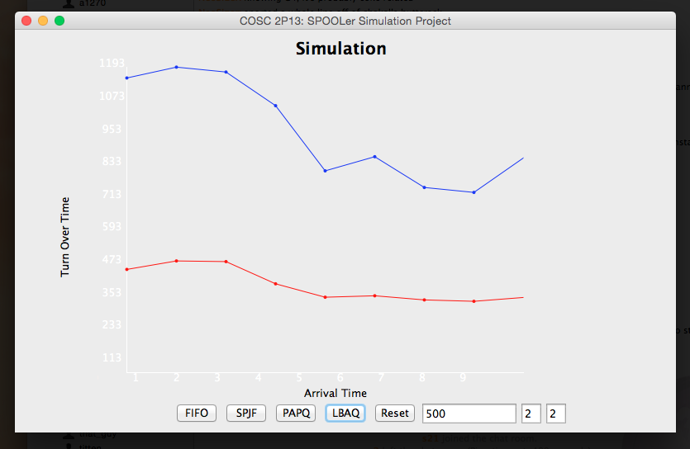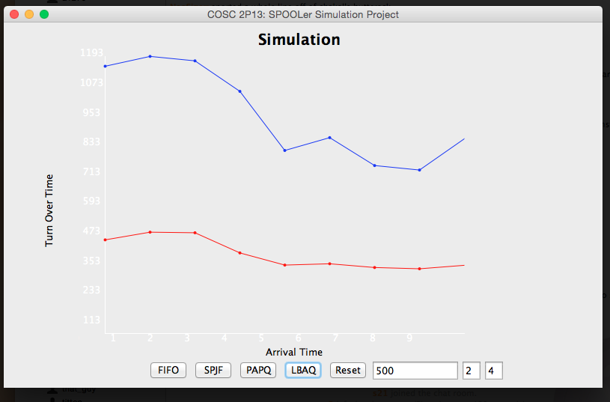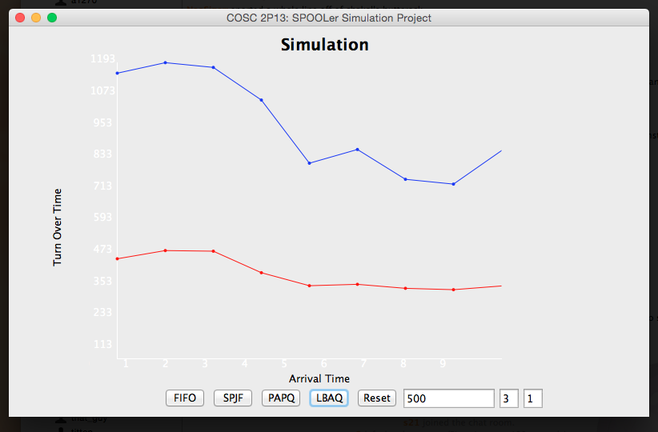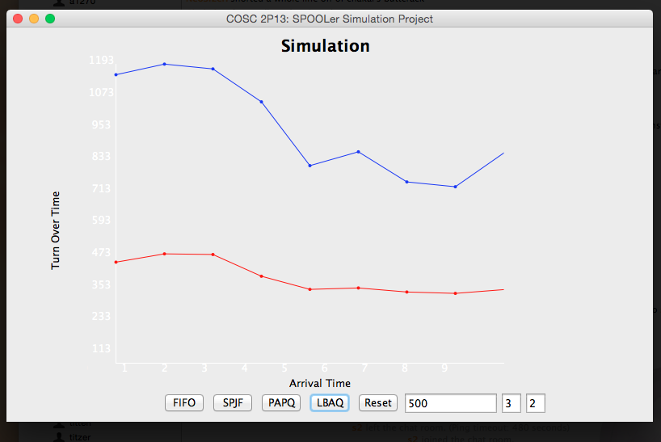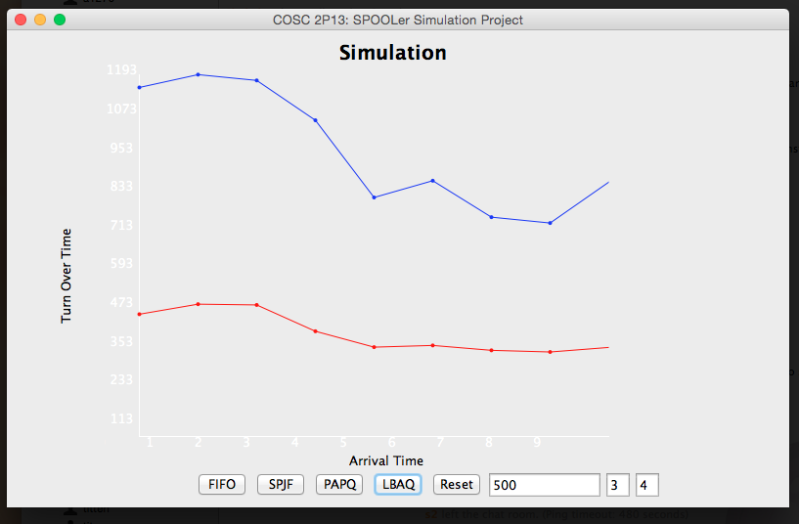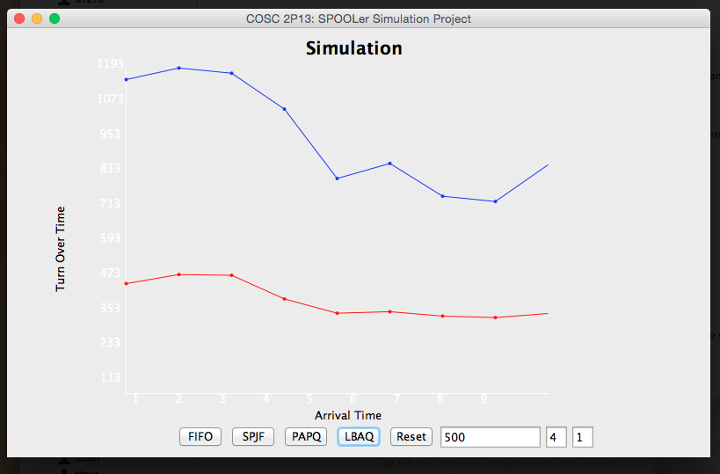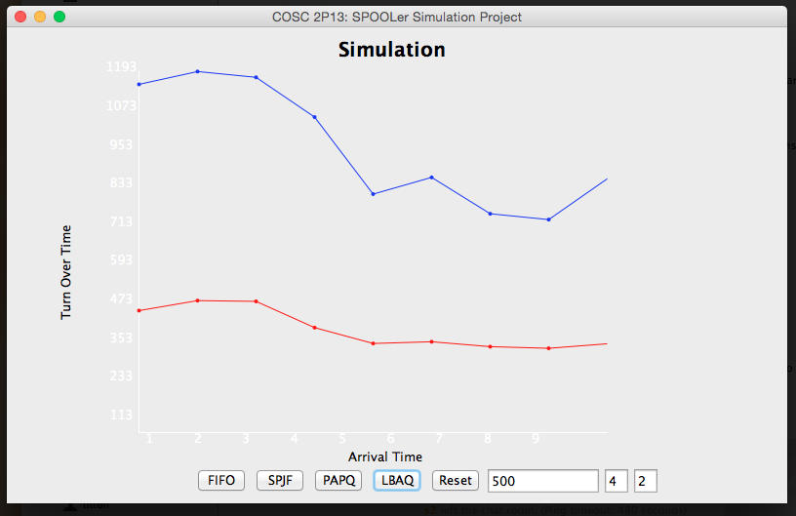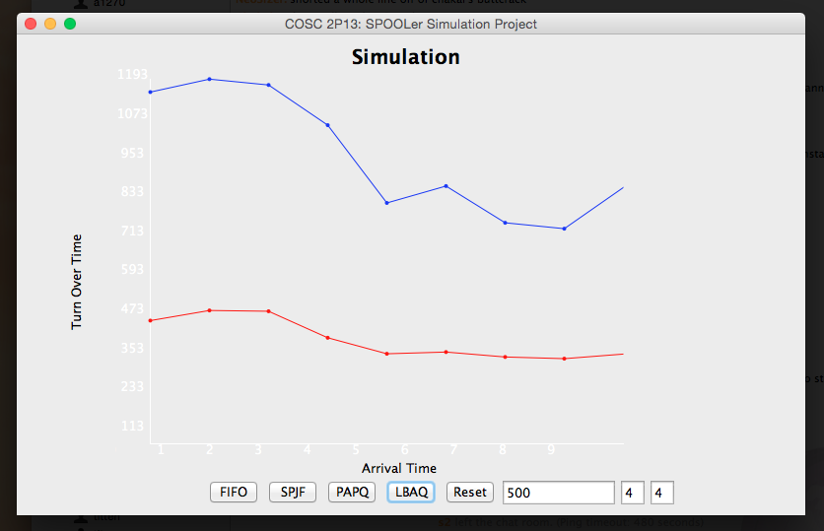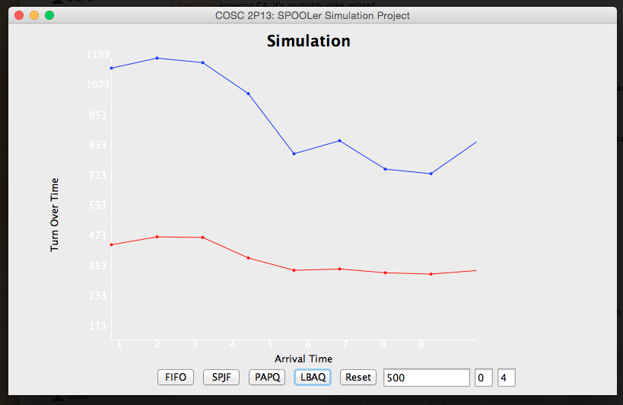

LBAQ:

A: 0 B: 1

Speed is: 1 Average:403.36 Max: 1151.18

Speed is: 2 Average:436.50 Max: 1193.51

Speed is: 3 Average:433.92 Max: 1174.39

Speed is: 4 Average:347.14 Max: 1042.93

Speed is: 5 Average:294.78 Max: 788.34

Speed is: 6 Average:300.40 Max: 843.62

Speed is: 7 Average:284.25 Max: 723.40

Speed is: 8 Average:278.80 Max: 704.06

Speed is: 9 Average:293.81 Max: 838.96

LBAQ:

A: 0 B: 2

Speed is: 1 Average:403.36 Max: 1151.18

Speed is: 2 Average:436.50 Max: 1193.51

Speed is: 3 Average:433.92 Max: 1174.39

Speed is: 4 Average:347.14 Max: 1042.93

Speed is: 5 Average:294.78 Max: 788.34

Speed is: 6 Average:300.40 Max: 843.62

Speed is: 7 Average:284.25 Max: 723.40

Speed is: 8 Average:278.80 Max: 704.06

Speed is: 9 Average:293.81 Max: 838.96

LBAQ:

A: 0 B: 4

Speed is: 1 Average:403.36 Max: 1151.18

Speed is: 2 Average:436.50 Max: 1193.51

Speed is: 3 Average:433.92 Max: 1174.39

Speed is: 4 Average:347.14 Max: 1042.93

Speed is: 5 Average:294.78 Max: 788.34

Speed is: 6 Average:300.40 Max: 843.62

Speed is: 7 Average:284.25 Max: 723.40

Speed is: 8 Average:278.80 Max: 704.06

Speed is: 9 Average:293.81 Max: 838.96

LBAQ:

A: 1 B: 1

Speed is: 1 Average:403.30 Max: 1151.18

Speed is: 2 Average:436.42 Max: 1193.51

Speed is: 3 Average:433.84 Max: 1174.39

Speed is: 4 Average:347.07 Max: 1042.93

Speed is: 5 Average:294.71 Max: 788.34

Speed is: 6 Average:300.34 Max: 843.62

Speed is: 7 Average:284.17 Max: 723.40

Speed is: 8 Average:278.71 Max: 704.06

Speed is: 9 Average:293.75 Max: 838.96

LBAQ:

A: 1 B: 2

Speed is: 1 Average:403.34 Max: 1151.18

Speed is: 2 Average:436.44 Max: 1193.51

Speed is: 3 Average:433.88 Max: 1174.39

Speed is: 4 Average:347.10 Max: 1042.93

Speed is: 5 Average:294.74 Max: 788.34

Speed is: 6 Average:300.36 Max: 843.62

Speed is: 7 Average:284.23 Max: 723.40

Speed is: 8 Average:278.75 Max: 704.06

Speed is: 9 Average:293.78 Max: 838.96

LBAQ:

A: 1 B: 4

Speed is: 1 Average:403.35 Max: 1151.18

Speed is: 2 Average:436.48 Max: 1193.51

Speed is: 3 Average:433.91 Max: 1174.39

Speed is: 4 Average:347.11 Max: 1042.93

Speed is: 5 Average:294.75 Max: 788.34

Speed is: 6 Average:300.37 Max: 843.62

Speed is: 7 Average:284.24 Max: 723.40

Speed is: 8 Average:278.78 Max: 704.06

Speed is: 9 Average:293.80 Max: 838.96

LBAQ:

A: 2 B: 1

Speed is: 1 Average:403.23 Max: 1151.18

Speed is: 2 Average:436.31 Max: 1193.51

Speed is: 3 Average:433.77 Max: 1174.39

Speed is: 4 Average:347.00 Max: 1042.93

Speed is: 5 Average:294.66 Max: 788.34

Speed is: 6 Average:300.26 Max: 843.62

Speed is: 7 Average:284.10 Max: 723.40

Speed is: 8 Average:278.65 Max: 704.06

Speed is: 9 Average:293.64 Max: 838.96

LBAQ:

A: 2 B: 2

Speed is: 1 Average:403.30 Max: 1151.18

Speed is: 2 Average:436.42 Max: 1193.51

Speed is: 3 Average:433.84 Max: 1174.39

Speed is: 4 Average:347.07 Max: 1042.93

Speed is: 5 Average:294.71 Max: 788.34

Speed is: 6 Average:300.34 Max: 843.62

Speed is: 7 Average:284.17 Max: 723.40

Speed is: 8 Average:278.71 Max: 704.06

Speed is: 9 Average:293.75 Max: 838.96

LBAQ:

A: 2 B: 4

Speed is: 1 Average:403.34 Max: 1151.18

Speed is: 2 Average:436.44 Max: 1193.51

Speed is: 3 Average:433.88 Max: 1174.39

Speed is: 4 Average:347.10 Max: 1042.93

Speed is: 5 Average:294.74 Max: 788.34

Speed is: 6 Average:300.36 Max: 843.62

Speed is: 7 Average:284.23 Max: 723.40

Speed is: 8 Average:278.75 Max: 704.06

Speed is: 9 Average:293.78 Max: 838.96

LBAQ:

A: 3 B: 1

Speed is: 1 Average:403.17 Max: 1151.18

Speed is: 2 Average:436.23 Max: 1193.51

Speed is: 3 Average:433.70 Max: 1174.39

Speed is: 4 Average:346.96 Max: 1042.93

Speed is: 5 Average:294.58 Max: 788.34

Speed is: 6 Average:300.18 Max: 843.62

Speed is: 7 Average:284.03 Max: 723.40

Speed is: 8 Average:278.57 Max: 704.06

Speed is: 9 Average:293.57 Max: 838.96

LBAQ:

A: 3 B: 2

Speed is: 1 Average:403.28 Max: 1151.18

Speed is: 2 Average:436.37 Max: 1193.51

Speed is: 3 Average:433.81 Max: 1174.39

Speed is: 4 Average:347.04 Max: 1042.93

Speed is: 5 Average:294.68 Max: 788.34

Speed is: 6 Average:300.30 Max: 843.62

Speed is: 7 Average:284.14 Max: 723.40

Speed is: 8 Average:278.68 Max: 704.06

Speed is: 9 Average:293.68 Max: 838.96

LBAQ:

A: 3 B: 4

Speed is: 1 Average:403.31 Max: 1151.18

Speed is: 2 Average:436.42 Max: 1193.51

Speed is: 3 Average:433.86 Max: 1174.39

Speed is: 4 Average:347.09 Max: 1042.93

Speed is: 5 Average:294.72 Max: 788.34

Speed is: 6 Average:300.35 Max: 843.62

Speed is: 7 Average:284.19 Max: 723.40

Speed is: 8 Average:278.75 Max: 704.06

Speed is: 9 Average:293.76 Max: 838.96

LBAQ:

A: 4 B: 1

Speed is: 1 Average:403.10 Max: 1151.18

Speed is: 2 Average:436.18 Max: 1193.51

Speed is: 3 Average:433.61 Max: 1174.39

Speed is: 4 Average:346.86 Max: 1042.93

Speed is: 5 Average:294.53 Max: 788.34

Speed is: 6 Average:300.12 Max: 843.62

Speed is: 7 Average:283.94 Max: 723.40

Speed is: 8 Average:278.47 Max: 704.06

Speed is: 9 Average:293.48 Max: 838.96

LBAQ:

A: 4 B: 2

Speed is: 1 Average:403.23 Max: 1151.18

Speed is: 2 Average:436.31 Max: 1193.51

Speed is: 3 Average:433.77 Max: 1174.39

Speed is: 4 Average:347.00 Max: 1042.93

Speed is: 5 Average:294.66 Max: 788.34

Speed is: 6 Average:300.26 Max: 843.62

Speed is: 7 Average:284.10 Max: 723.40

Speed is: 8 Average:278.65 Max: 704.06

Speed is: 9 Average:293.64 Max: 838.96

LBAQ:

A: 4 B: 4

Speed is: 1 Average:403.30 Max: 1151.18

Speed is: 2 Average:436.42 Max: 1193.51

Speed is: 3 Average:433.84 Max: 1174.39

Speed is: 4 Average:347.07 Max: 1042.93

Speed is: 5 Average:294.71 Max: 788.34

Speed is: 6 Average:300.34 Max: 843.62

Speed is: 7 Average:284.17 Max: 723.40

Speed is: 8 Average:278.71 Max: 704.06

Speed is: 9 Average:293.75 Max: 838.96

**LBAQ:**

The different between from A and B is very small, only a few decimal different from the different constants. Noticing how LBAQ is very similar to SPJF queue in terms of performances.

**5. Conclusion**

*By simulating the SPOOLer we were able to see differences from the raw data and graphs, there were a few differences between some of the queues response time. From the* analysis *we were able to understand the different methods of scheduling queues on which methods are the best. FIFO and PAPQ were identical in every aspect of the simulation by the average turn overtime and the maximum turnover time. LBAQ A:0 B:1 to LBAQ A:4 B:4 were almost the same. There were some differences in average and maximum turnover time. However the different wasn’t significant, only different is by a few decimals/milliseconds.*

*SPJF:*

Speed is: 1 Average:367.55 Max: 1128.51

Speed is: 2 Average:388.61 Max: 1174.84

Speed is: 3 Average:380.78 Max: 1132.24

Speed is: 4 Average:311.08 Max: 1025.60

Speed is: 5 Average:265.36 Max: 766.07

Speed is: 6 Average:270.63 Max: 810.80

Speed is: 7 Average:254.35 Max: 706.06

Speed is: 8 Average:245.68 Max: 697.53

Speed is: 9 Average:261.18 Max: 813.64

LBAQ:

A: 0 B: 1

Speed is: 1 Average:403.36 Max: 1151.18

Speed is: 2 Average:436.50 Max: 1193.51

Speed is: 3 Average:433.92 Max: 1174.39

Speed is: 4 Average:347.14 Max: 1042.93

Speed is: 5 Average:294.78 Max: 788.34

Speed is: 6 Average:300.40 Max: 843.62

Speed is: 7 Average:284.25 Max: 723.40

Speed is: 8 Average:278.80 Max: 704.06

Speed is: 9 Average:293.81 Max: 838.96

LBAQ:

A: 4 B: 4

Speed is: 1 Average:403.30 Max: 1151.18

Speed is: 2 Average:436.42 Max: 1193.51

Speed is: 3 Average:433.84 Max: 1174.39

Speed is: 4 Average:347.07 Max: 1042.93

Speed is: 5 Average:294.71 Max: 788.34

Speed is: 6 Average:300.34 Max: 843.62

Speed is: 7 Average:284.17 Max: 723.40

Speed is: 8 Average:278.71 Max: 704.06

Speed is: 9 Average:293.75 Max: 838.96

*Comparing SPJF to LBAQ at around 500 jobs request, surprisingly there was a different, in approximately 40 seconds. Over all, SPJF seems to be the fastest of all the algorithms on average. The only down side with SPJF is starvation and variance in response time. Some task might take a lone time.*

**6. References**

**Posisson Distribution:**

<http://en.wikipedia.org/wiki/Poisson_distribution#Generating_Poisson-distributed_random_variables>

**The exponential Distribution**

<http://preshing.com/20111007/how-to-generate-random-timings-for-a-poisson-process/>

**Generate Poisson Arrival in Java for the program**

<http://stackoverflow.com/questions/9832919/generate-poisson-arrival-in-java>

<http://stackoverflow.com/questions/2206199/how-do-i-generate-discrete-random-events-with-a-poisson-distribution/5615564#5615564>

**Library used with the program and project**

<http://maths.uncommons.org/>

**Using a library for the GUI, for making the text vertical**

<https://tips4java.wordpress.com/2009/02/21/vertical-label-ui/>

**7. How to use the program**

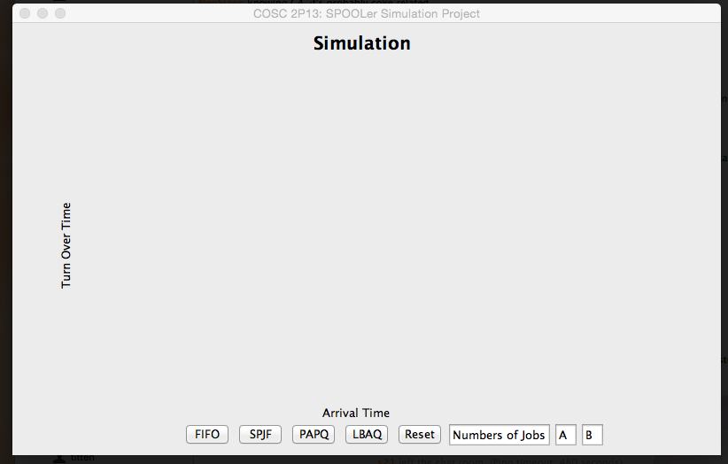

* The program is written entirely in Java, and using Java swing to create the user interface.
* This is the default GUI when the program starts up. There are four different queues to select from. FIFO, SPJF, PAPQ and LBAQ.
* The textbox “Number s of Jobs” is where the users input the numbers of jobs. The program will generated the numbers of pages and arrival time randomly base on Poisson and exponential Distribution.
* A and B are constants chosen by the users. The user pick A from 0-4, B from 1-4 excluding 3.
* The program will generate 9 different speeds and graph the average and maximum for each queue.
* If the user tried to select a queue without inputting numbers of jobs, a pop up window will let the user know it’s an error and needs to input number of jobs.
* If the user wants to input a different number of jobs, they will need to hit the reset button to do so.



* How the program looks when it’s running. On the X-axis is the arrival speed time from 1 to 9. On the Y-axis is the turnaround time. The red line is the average turn around time, and the blue line is the maximum turn around time.